**Aim:- Apply the what – if Analysis for data visualization. Design and generate**

**necessary reports based on the data warehouse data.**

A book store and have 100 books in storage. You sell a certain % for the highest price of $50

and a certain % for the lower price of $20.

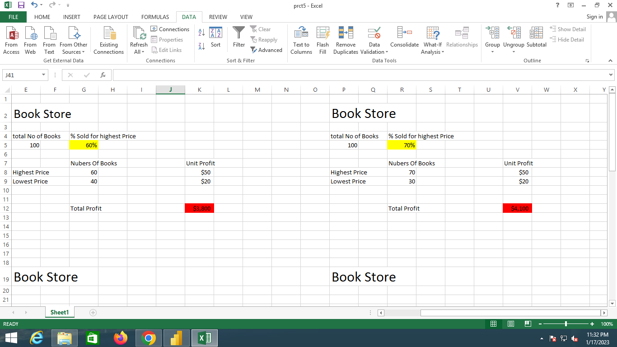

If you sell 60% for the highest price, cell D10 calculates a total profit of 60 * $50 + 40 * $20

= $3800.

Create Different Scenarios

But what if you sell 70% for the highest price? And what if you sell 80% for the highest price?

Or 90%, or even 100%? Each different percentage is a different scenario. You can use the

Scenario Manager to create these scenarios.

Note: You can simply type in a different percentage into cell C4 to see the corresponding result

of a scenario in cell D10. However, what-if analysis enables you to easily compare the results

of different scenarios. Read on.

**1. On the Data tab, in the Forecast group, click What-If Analysis.**

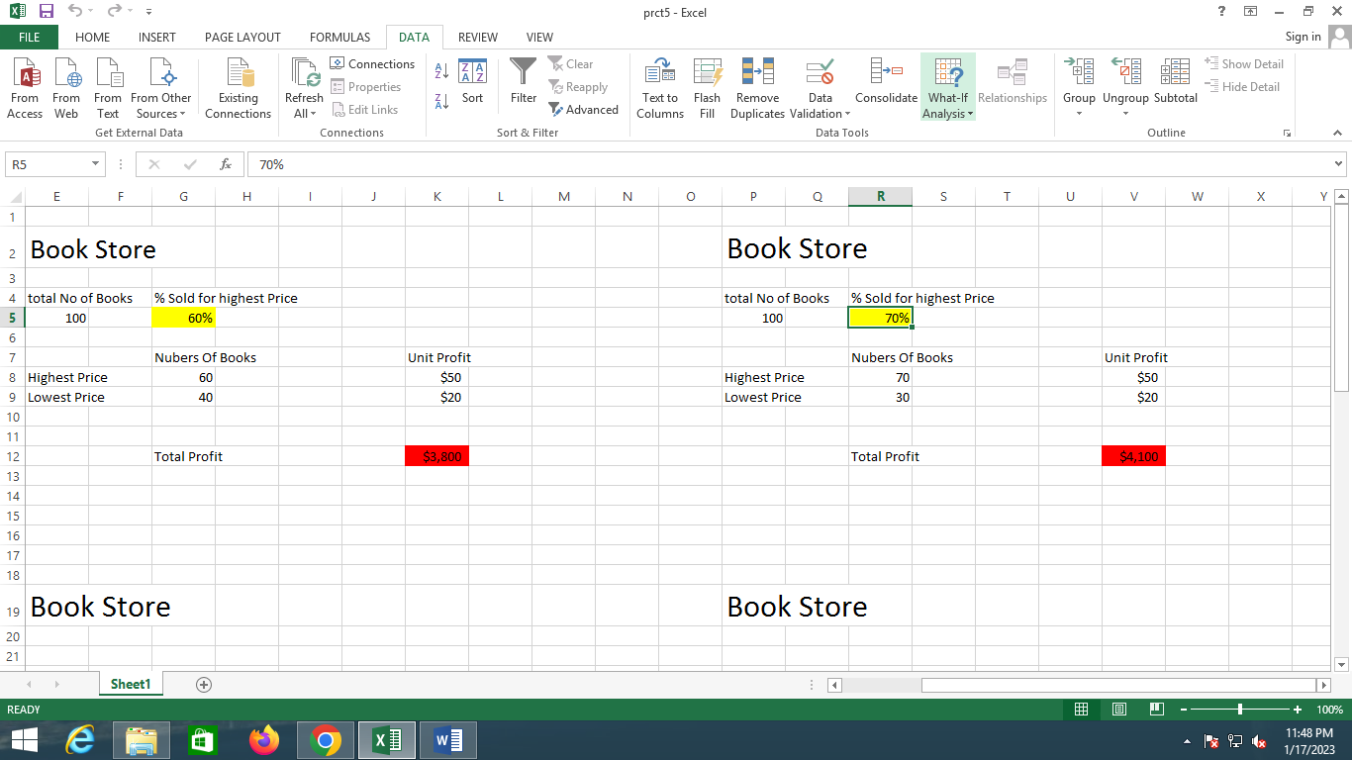

**2. Click Scenario Manager.**

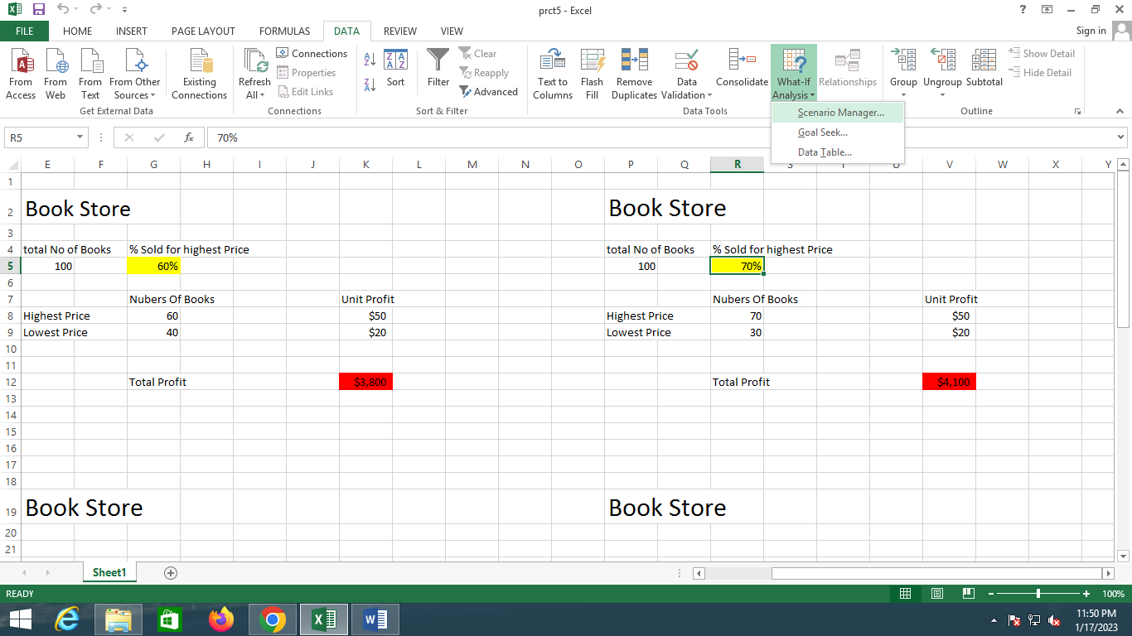

**The Scenario Manager dialog box appears.**

**3. Add a scenario by clicking on Add.**

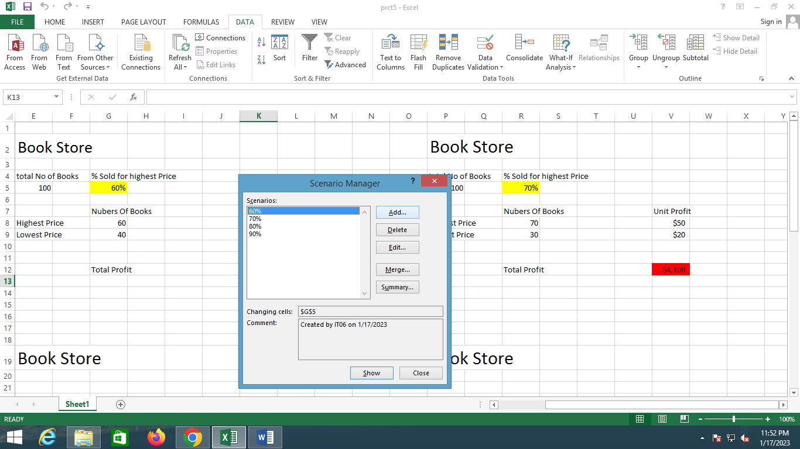

**4. Type a name (60% highest), select cell C4 (% sold for the highest price) for the**

**Changing cells and click on OK.**

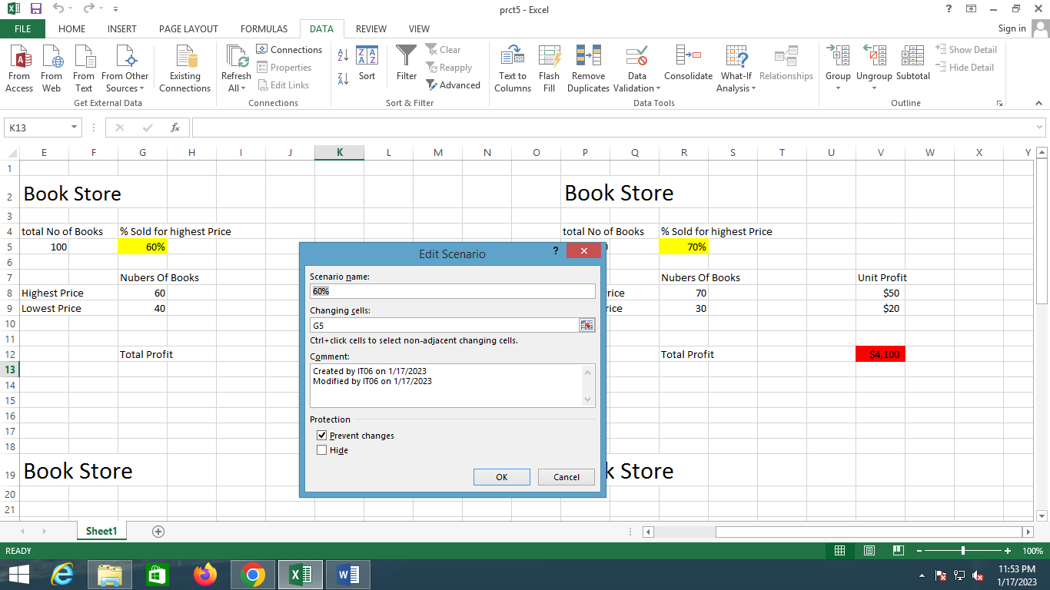

**5. Enter the corresponding value 0.6 and click on OK again.**

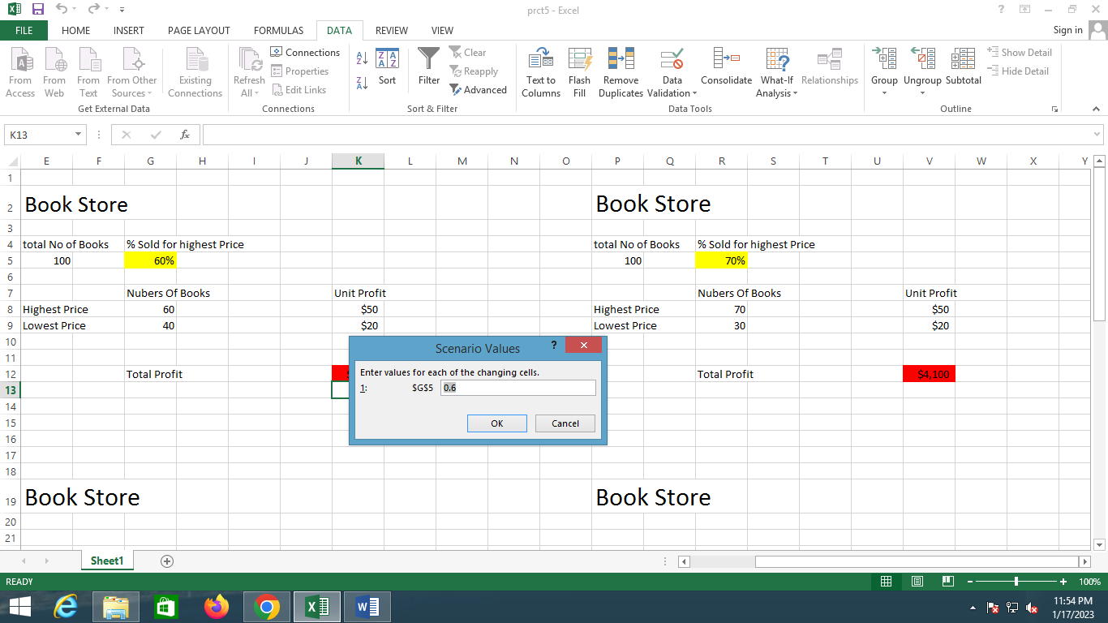

**6. Next, add 4 other scenarios (70%, 80%, 90%).**

**Finally, your Scenario Manager should be consistent with the picture below:**

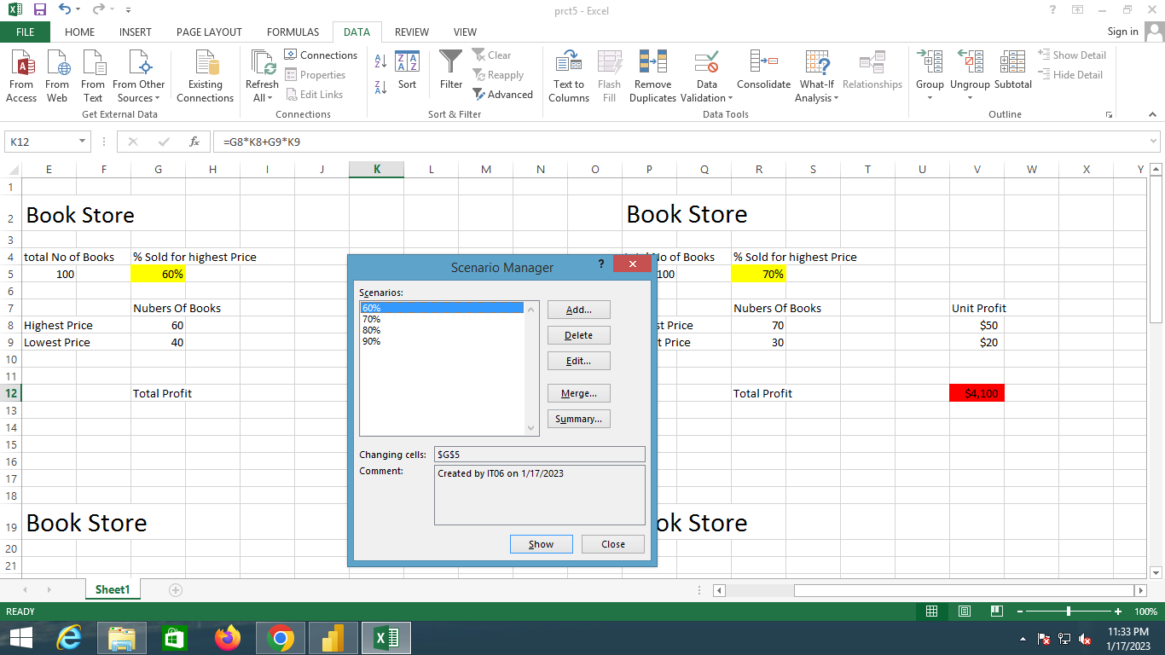

**Output:-**



